Marcia Wilson owns and operates Marcia’s Dry Cleaning, which is an upscale dry cleaner in a well-to-do suburban neighborhood. Marcia makes her business stand out from the competition by providing superior customer service. She wants to keep track of each of her customers and their orders. Ultimately, she wants to notify them that their clothes are ready via e-mail. To provide this service, she has developed an initial database with several tables. Three of those tables are the following:

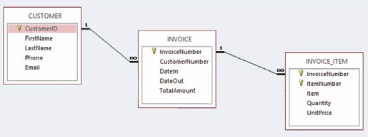

Write down the SQL statement for each question. You don’t need to show the output table. I will provide the database in case you would like to check your answers. But again, all what I need is the SQL statements.

1. Show all data in each of the tables (each table separately).

SELECT *

FROM CUSTOMER;

SELECT *

FROM INVOICE;

SELECT *

FROM INVOICE_ITEM;

1. List the LastName, FirstName, and Phone of all customers.

SELECT FirstName, LastName, Phone

FROM CUSTOMER;

1. List the LastName, FirstName, and Phone for all customers with a FirstName of “Nikki”.

SELECT FirstName, LastName, Phone

FROM CUSTOMER;

WHERE FirstName = “Nikki”;

1. List the LastName, FirstName, and Phone of all customers whose first name starts with 'B'.

SELECT FirstName, LastName, Phone

FROM CUSTOMER;

WHERE FirstName LIKE “B%”;

1. List the LastName, FirstName, and Phone of all customers whose last name includes the characters 'cat'.

SELECT FirstName, LastName, Phone

FROM CUSTOMER;

WHERE LastName LIKE ‘%cat%’;

1. List the LastName, FirstName, and Phone for all customers whose second and third digits (from the left) of their phone number are 23. For example, any phone number with an area code of ‘723’ would meet the criteria.

SELECT FirstName, LastName, Phone

FROM CUSTOMER;

WHERE Phone Like ‘_23%’;

1. Determine the maximum and minimum TotalAmount.

SELECT MAX(TotalAmount)

FROM INVOICE;

SELECT MIN(TotalAmount)

FROM INVOICE;

1. Determine the average TotalAmount.

SELECT AVG(TotalAmount)

FROM INVOICE;

1. Count the number of customers.

SELECT COUNT(TotalAmount)

FROM INVOICE;

1. Group customers by LastName and then by FirstName.

SELECT FirstName, LastName

FROM CUSTOMER;

GROUP BY LastName;

GROUP BY FirstName;

1. Count the number of customers having each combination of LastName and FirstName.

SELECT COUNT( LastName, FirstName )

FROM CUSTOMER;

WHERE FirstName (+)= LastName;

**End of Assignment #2. Good Luck**